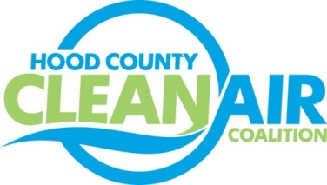
Meeting: Tuesday, August 4, 2015
Neely House
304 East Rucker Street, Granbury, Texas 76048
8:30-10:00 a.m.

Agenda

- Call Meeting to Order
- EPA Updates – Carl Young
- Regional Updates – Michelle McKenzie
  - Air Quality Funding Opportunities for Vehicles
  - National Drive Electric Week, September 19
- Local Updates – Michelle McKenzie
  - Review of June and July Meeting Summary
  - Review of Projects
    - Monthly Budget Review for May and June
    - Status of Projects
      - Bike Equipment
      - Propane Refueling Stations
      - FY 16/17 PGA and Contract Extension
  - Administration for the HCCAC
    - Consideration of Location for new HCCAC bank account
    - Record Book
  - Ozone Advance 2015 Update
  - Reports
    - North Central Texas Stewardship Forum Webinar: Multi-family Recycling
    - Air North Texas Meeting
    - CenSARA Conference Call
    - Ozone Update through July
    - TxDOT Public Meeting
5.) Discussion
6.) Adjourn

